PROJECT DESIGN PHASE II

DATA FLOW DIAGRAM AND USER STORIES

|  |  |
| --- | --- |
| Date | 16 October 2022 |
| Team ID | PNT2022TMID08163 |
| Project Name | DEMANDEST – AI POWERED FOOD DEMAND FORECASTER |
| Maximum Marks | 4 Marks |

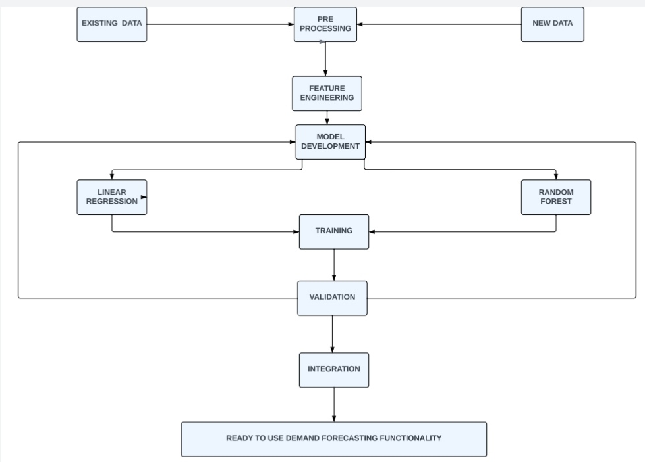

|  |  |  |  |  |  |  |
| --- | --- | --- | --- | --- | --- | --- |
| **User Type** | **Functional**  **Requirement (Epic)** | **User Story Number** | **User Story / Task** | **Acceptance criteria** | **Priority** | **Release** |
| Customer (Web user) | Registration | USN-1 | As a user, I can register for the application by entering my email, password, and confirming my password. | I can access my account / dashboard | High | Sprint-1 |
|  | Verification | USN-2 | As a user, I will receive confirmation email once I have registered for the application | I can receive confirmation email & click confirm | High | Sprint-1 |
|  | Login | USN-3 | As a user, I can login to the application by entering email and password. | Check whether password and email is correct | High | Sprint-1 |
|  | Dashboard | USN-4 | If the email id and password is correct, the user can log in to the application otherwise it shows ‘incorrect password or Id’. | View the dashboard of user who is log in | High | Sprint-1 |
| Customer Care Executive | Help | USN-5 | If the user faces any issues, he/she can report it to our mail id. | Report option will be available in web app | High | Sprint-2 |
| Administrator | Verification | USN-6 | Administrator also has unique Id and password to login. He has additional users to organize the users of this web app | Check whether password and email is correct | High | Sprint-3 |